EXPT NO:7B | DATA VISUALIZATION USING TABLEAU

AIM:
To import, transform, analyze, and visualize data using Tabuleau Desktop and create interactive dashboards and reports for decision-making.
ALGORITHM:
  - Start
  - Open Tableau Desktop.
  - Connect to the required dataset.
  - Import and check the data.
  - Clean and transform the data if required.
  - Create worksheets using suitable fields.
  - Create visualizations such as bar charts, line charts, pie charts, and tables.
  - Combine the worksheets to create an interactive dashboard.
  - Add filters and slicers for better analysis.
  - Analyze the dashboard and identify important insights.
  - Stop.
OUTPUT:

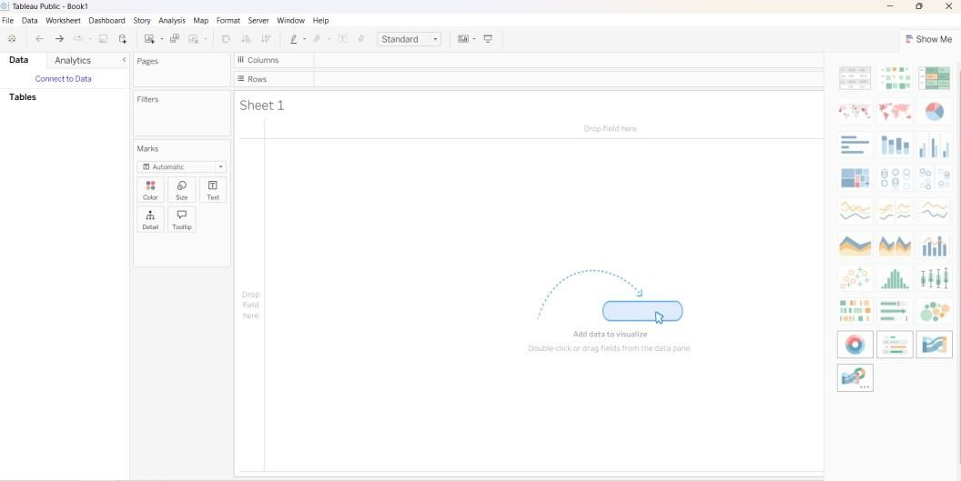
Imported dataset displayed in Data View:

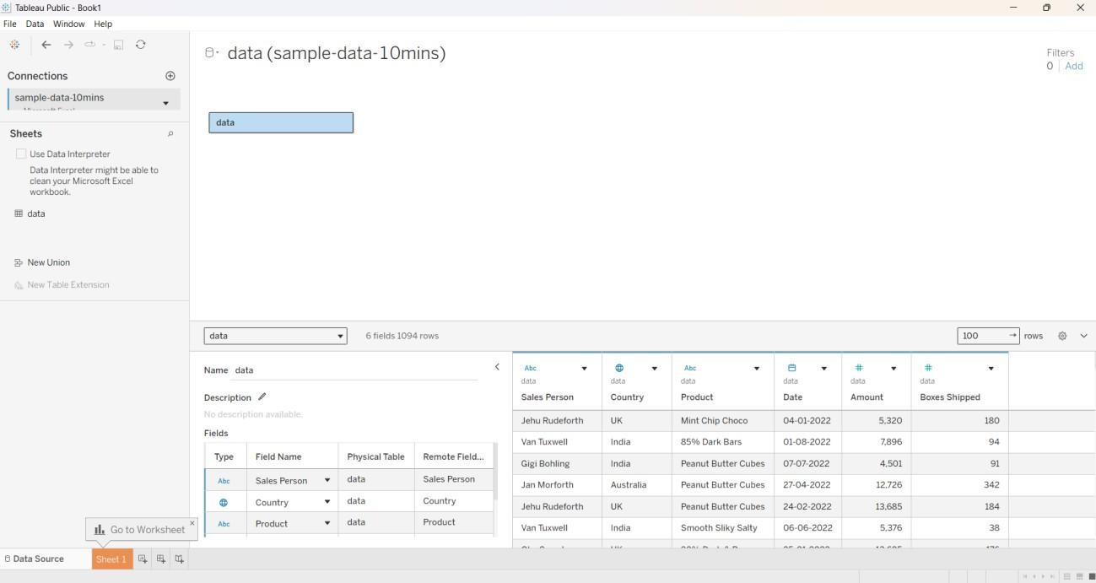
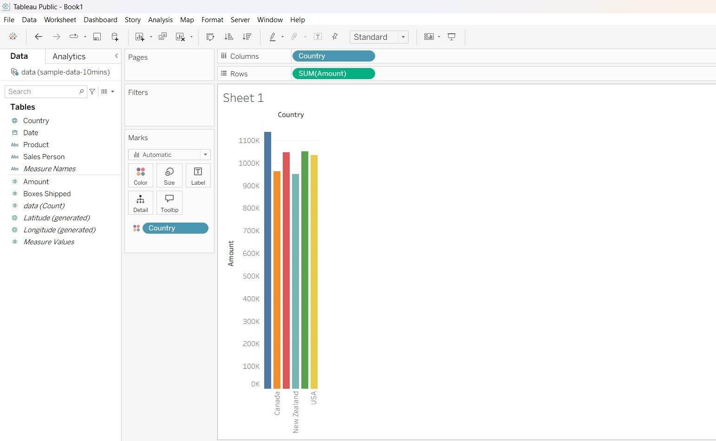

Making a Top 10 sales:

1).Apply filters:

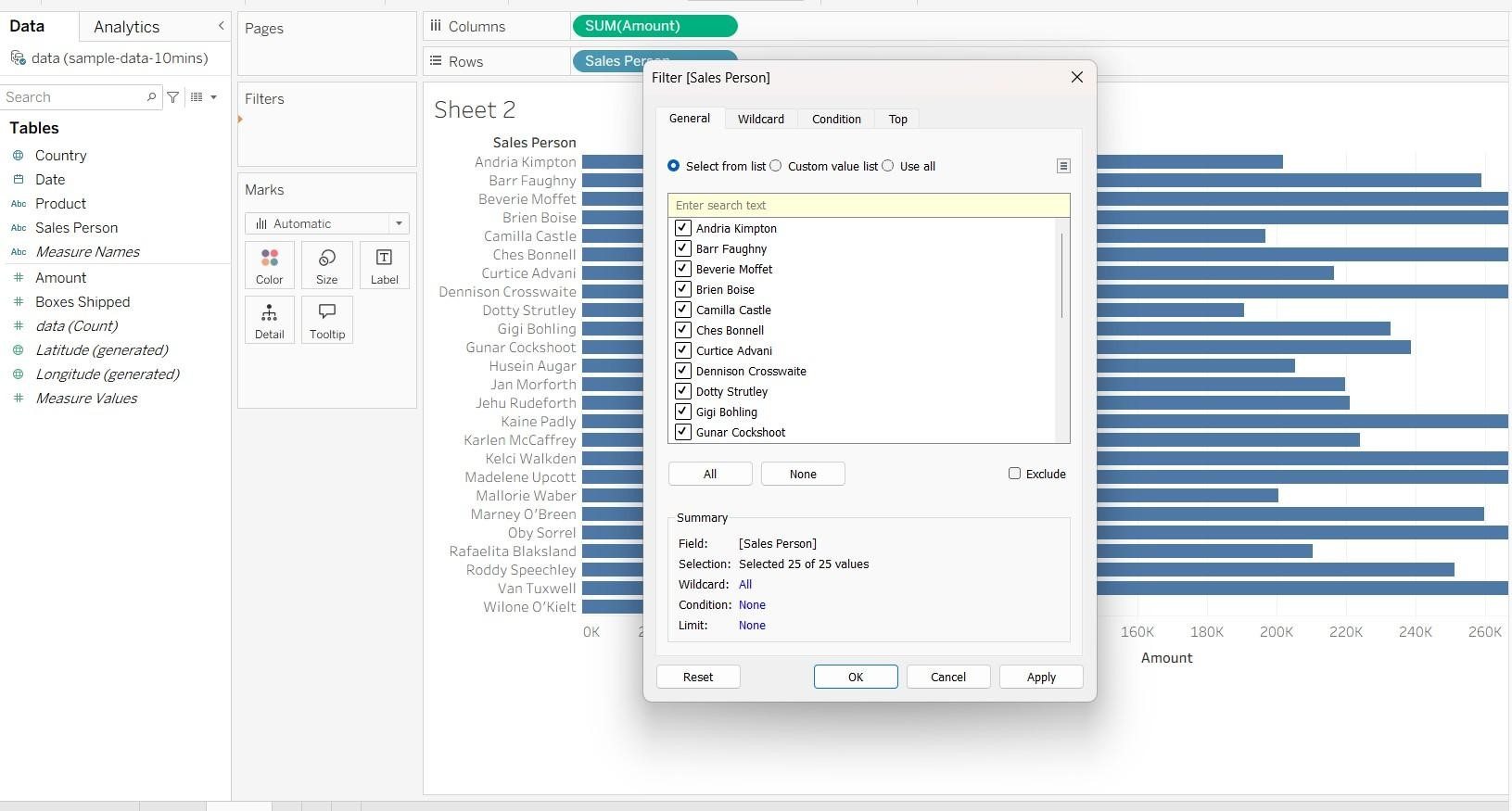

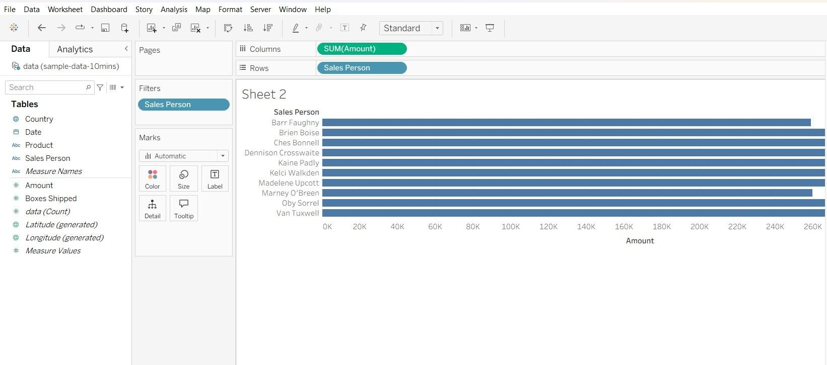

2). Make DashBoard in Tabulaue:

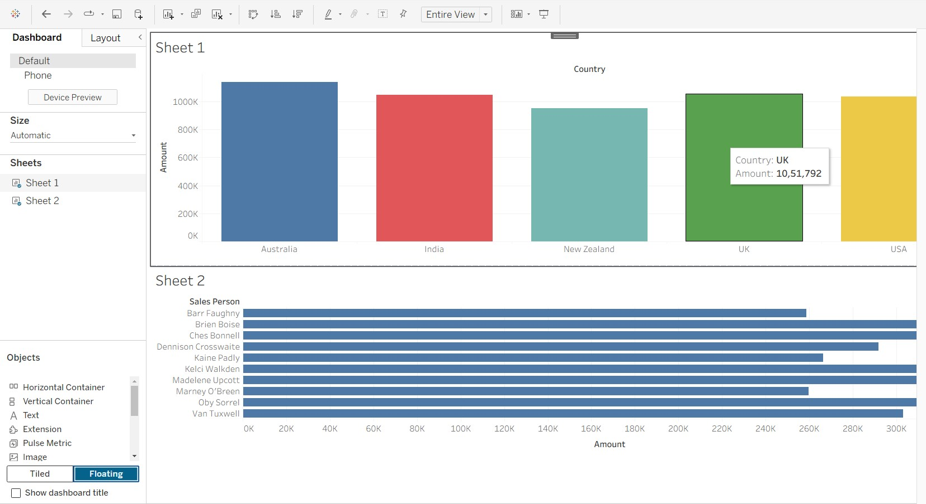

3). Add Business Summary:
